|  |  |  |  |
| --- | --- | --- | --- |
| **Name of Student: NINAD AVINASH PATIL** | | | |
| **Roll No: 33** | | **Lab Practical Number: 1.4** | |
| **Title of Lab Practical: Create a Window application to calculate the age of a person by providing input as birth date and current date. Current date and Birth date must be in long string format and display the age in terms of years.** | | | |
| **DOP: 17/02/2021** | | **DOS: 24/02/2021** | |
| **CO Mapped: CO1** | **PO Mapped: PO3, PO5, PO7,**  **PO12, PSO1, PSO2** | **Faculty Signature:** | **Marks:** |

**Practical No 1.4**

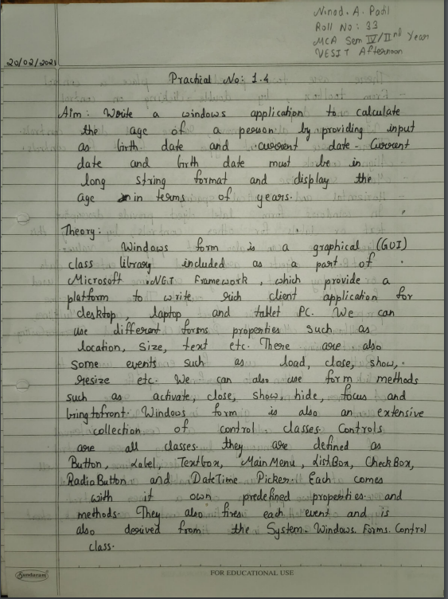

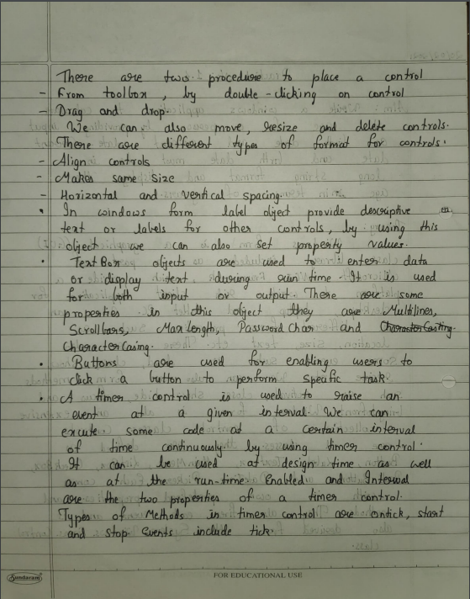

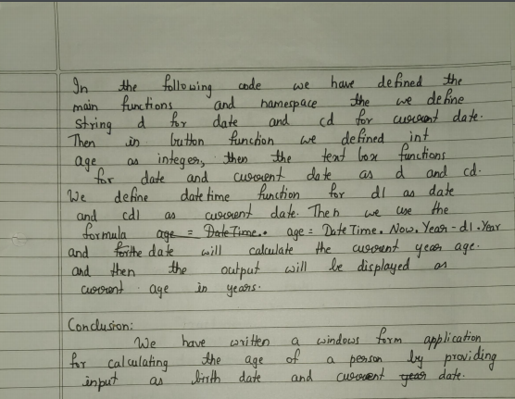

**Code:**

using System;

using System.Collections.Generic;

using System.ComponentModel;

using System.Data;

using System.Drawing;

using System.Linq;

using System.Text;

using System.Windows.Forms;

namespace WindowsFormsApplication4

{

public partial class Form1 : Form

{

String d, cd;

public Form1()

{

InitializeComponent();

}

private void label1_Click(object sender, EventArgs e)

{

}

private void textBox1_TextChanged(object sender, EventArgs e)

{

}

private void label2_Click(object sender, EventArgs e)

{

}

private void textBox2_TextChanged(object sender, EventArgs e)

{

}

private void label3_Click(object sender, EventArgs e)

{

}

private void button1_Click(object sender, EventArgs e)

{

int age;

d = textBox1.Text;

cd = textBox2.Text;

DateTime d1 = DateTime.ParseExact(d, "dd/mm/yyyy", null);

DateTime cd1 = DateTime.ParseExact(cd, "dd/MM/yyyy", null);

age = DateTime.Now.Year - d1.Year;

DateTime now = DateTime.Now;

if (d1.Month > now.Month)

{

label3.Text = "Your Current Age is: " + age + " years";

}

else

{

age = age - 1;

label3.Text = "Your Current Age is: " + age + " years";

}

}

}

}

**Output:**

